Intro to Long Range Shooting
Presented by Long Range Shooters of Utah, LLC

Thank you for registering for the Intro to Long Range Shooting Course with LRSU. We’re excited to have you as our guest and to help you shoot farther and more effectively than you ever thought possible.

Considerations:
- Achieving the EXTRAORDINARY - Long range shooting is truly something extraordinary and we should expect it to require some extraordinary measures to achieve. This includes specialized equipment that meets strict performance and feature requirements that are necessary for the task. Please read and carefully consider what is outlined below and contact us right away if you have any questions or concerns about your current gear. As a full-service FFL we carry most of these items and would be happy to assist you.
- Being “shooter focus” means being “equipment focused” first - At its core, long range shooting is a systematic process of eliminating variables in order to achieve precision and accuracy. The three great variables are the shooter, his/her equipment, and conditions. The best way for us to focus on you as the shooter and improving his/her abilities behind the rifle is to eliminate the other two variables completely. This means equipping you with the absolute best shooting rifle/ammo/equipment possible so that any remaining error can then be attributed solely to the shooter and systematically addressed. For that reason, it’s critical that your equipment meets and hopefully, exceed the standards outlined below. If not, we recommend considering a rental package or contact us to discuss options for improving your current setup.
- Please read the following checklist carefully and contact us with any questions. This can be a very expensive sport, but it doesn’t have to be if you’re very careful and deliberate about what you buy. We’re here to help you reach your goals and ensure your success in class.

Required Equipment:

We carry many of these items in-house and can generally meet or beat any online price for them. Please email us at info@longrangeshootersofutah.com or call Bryce at 801 913 4463 for assistance.

1 - Eye and Ear Protection. It's up to you to choose PPE that fits and works best for you. Electronic muff generally offer better sound quality and protection but can interfere with your cheek weld and glasses whereas in-ear options do not. Test your gear in advance to ensure it works well for you.
- In-ear options: Otte Engineering Walker Caldwell
- Muff options: Howard Leight Sport Walker
- Eye pro: Wiley X. SSP Multi-lens Bolle Magpul Leupold
2 - Rifle: Must be in safe, working order, and capable of shooting a 1 MOA or better 5-shot group at 100 yards (5 shots inside of a 1" circle). Please test your rifle and ammo well before class to ensure it meets this standard. Email us a photo of your 5-shot group if you're unsure.
RIFLE RENTALS: We have a limited number of standard and premium rental packages available. Both include a precision rifle, optic, bubble level, sidewinder DOPE card, bipod, rear bag, shooting mat, and 100 rounds of match-grade factory ammunition. Additional ammo is available for $45 per box of 20 (subject to change). Standards rentals are LRSU Tikka Builds in 6.5 Creedmoor with Vortex Viper PST Gen II FFP 5-25 optic for $299. Premium rentals are custom rifles chambered in 6.5 Creedmoor with Leupold Mark 5HD 5-25 optics for $399.
If you’re concerned about the recoil or cost of shooting your own rifle for the class you’re welcome to rent a rifle to use for the bulk of the class and bring your own rifle to setup and shoot as well.
3 - Match-Grade Ammunition: Specifically designed for long-range precision and will maximize the precision of your rifle. Match ammo will exclusively use high ballistic coefficient boat tail bullets and is extensively tested to ensure the most consistent muzzle velocity from shot to shot. Handloaded ammo is permitted as long as it does not exhibit signs of high pressure (ejector marks, stiff bolt lift, and blown primers). Armor-piercing (green tip), incendiary, tracers, and HE rounds and NOT ALLOWED at the range or in the class.
We recommend Hornady Match or Hornady Precision Hunter primarily but Sig Elite Match, Prime, and Federal Gold Medal Match are also solid. Please test your rifle and ammo well before class to ensure you can shoot a 1 moa or better 5-shot group at 100 yards. If not, call us.
Quantity: Most students will use roughly 100 -120 rounds during class. Those who stay after to shoot out to a mile or attempt the longer milk jug challenges will want 140-160 rounds. If you're having difficulty sourcing ammo, try these websites:﻿ ammoseek.com, primeammunition.com, unknownmuntions.com, coppercreekcartridgeco.com, Brownells.com, Creedmoorsports.com, and Natchez.com. As a last resort, we do carry small quantities of 223, 308, 6mm Creedmoor, 6.5 Creedmoor, 6.5 PRC, and 300 PRC to help supplement students as needed.

Magnums & Large Calibers (7mm, 300 WM, 300 PRC, 338, etc.) There are no caliber restrictions for the course however we generally advise against using a magnum for the bulk of the course for four reasons.
- Availability of match ammo.
- Cost. For what you'll spend on 100 rounds of match-grade magnum ammo you would literally save money by renting one of our 6.5 Creedmoor packages which you'll likely enjoy shooting much better due to the mild recoil.
- Recoil. The ideal precision rifle has zero recoil allowing the shooter to spot his own bullet as it travels to the target and make corrections. This is extremely difficult with a magnum unless it weighs 16 lbs+. Also, the additional movement will occur before the bullet has left the barrel and negatively affects your group size. This is why many manufacturers will not guarantee the same level of performance for the same rifle if chambered in a magnum cartridge.
- Overkill. The bulk of the class will be 100 to 1000 yards and a magnum just isn't necessary. I'd shoot the bulk of the class with a mid-caliber and maybe bring our the magnum for the extreme long-range milk jug challenge after class.
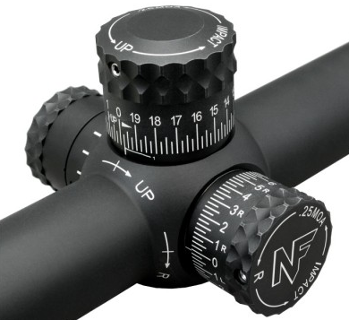
4 - Quality optics with external turrets and quality scope rings. Your optic is the most important component in your weapons system and best investment you can make. Choose wisely.
Much of this course will be teaching you how to calculate a shooting solution with a ballistics app and then adjusting for the drop and drift of your bullet using the elevation and windage turrets on your riflescope or your reticle. For that reason, it is REQUIRED that your optic have externally adjustable turrets.
Ample Elevation Adjustment: It’s important that your optic has ample elevation adjustment to reach at least 1000 yards. Common calibers like the .308, 6.5 Creedmoor, and 300 Win Mag will require between 19 and 29 MOA (5-9 Mils) to do so. Mid-range scopes ($500-1000) generally have a 60-90 MOA of total adjustment and high-end optics have 90-120 MOA (25-30 mils) but bear in mind that your 100-yard zero may leave you with only 50-75% of that. Most rifles come with a 20 MOA rail to help maximize your total adjustment. If yours is 0 moa, consider getting a 20-30 moa.
You’ll never regret upgrading to a top-of-the-line optic. We carry Nightforce, Leupold, Vortex, EOTech, and many more. Call us if you need help with optics, rings, & bubbles.
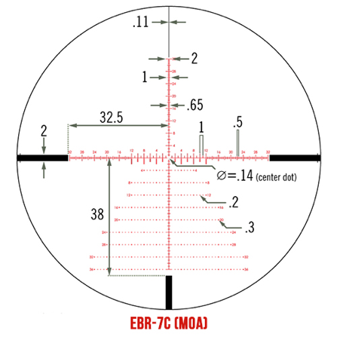
- Vortex Viper PST Gen II 5-25 FFP EBR-7C Mil or MOA - $949,
- Leupold Mark 5HD 5-25 FFP Mil or MOA $2099 - $2399
- Vortex Razor Gen III 4.5 – 27 Gen 2 Mil or MOA - $2999
- Nightforce ATACR F1 5-25 Mil or MOA starts at $3100
- Nightforce ATACR F1 7-35 Mil or MOA starts at $3600
- ARC M-brace Rings -$179.99, M-brace mounts $279.99
We recommend bringing a printout of your reticle showing the values of the hashes to help you spot and correct your shots.
Quality Scope Rings or Mount: Do not scrimp on your rings. Buy robust, quality rings from a reputable brand, otherwise you risk your scope shifting leading to a lot of wasted ammo, time, and frustration. Rings should be torqued accurately to manufacturers specifications using an inch-pound NOT foot-pound torque wrench. Most rings require 15-25 in/lbs. whereas rail cross bolts require 45-65 in/lbs. ALWAYS follow the recommended the torque specs of your rings and optic.
We recommend American Rifle Co (ARC) , Spuhr, Nightforce, Vortex Precision rings, Badger Ordinance, APA, and a few others. We generally will have ARC rings available at class.
5 - Bubble Level for your optic. Video Demonstration
Example: 30mm & 34mm Vortex Bubble Level - Rail Mounted Level – MDT Send-It Level (available at class)
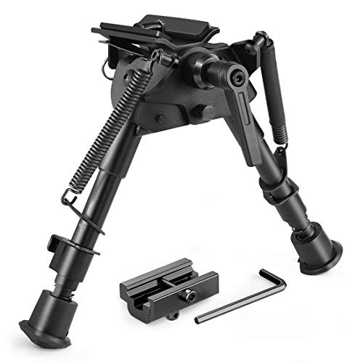
6 - Quality bipod with pod lock capable of canting from side to side so you can level your rifle/optic. Having a steady foundation is pivotal to creating precision and it starts with a quality bipod. TRUST US, DON'T SCRIMP ON YOUR BIPOD!
Bipods we carry & recommend:
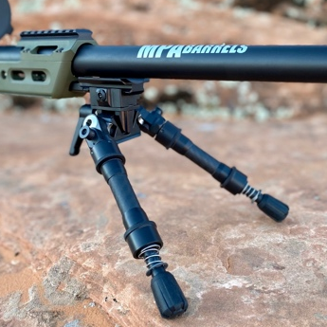
- Harris BRMS 6-9" or 9-13" with an aftermarket pod lock installed. Mounts to a sling swivel stud - $125 from LRSU with our pod lock installed.
- 8-11" or 10-14" Evolution Bipods - Made in Utah. Patented interchangeable/stackable carbon fiber legs. Mount to Picatinny & Arca rails. - $349 - 495
- MDT Ckye pod - $599 - $999
Evolution
- Accutac - $349+
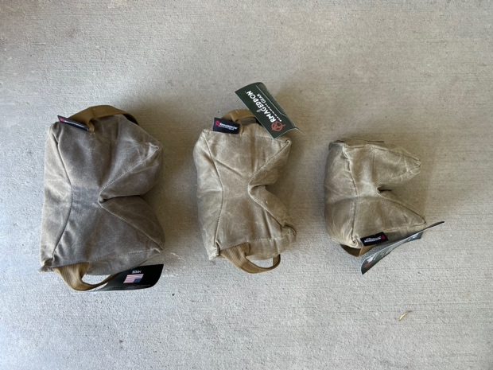
Bipods to avoid: Caldwell, UTG, Magpul, Leapers, Swagger, or any knock-off of a Harris or Atlas from Amazon. They may look the same but they are generally made in China and lack the quality and rigidity you want. There are dozen of knockoffs of the Harris bipod made by various companies like Caldwell. Knock-off Atlas bipods from Amazon. Magpul bipods have also struggled to provide the level of stability you will want to maximize precision.
Schmedium
Pint Size
OG
7 - Rear bags. Finding the right rear bag for your body-type and rifle configuration is critical to building a solid shooting position. The geometry, fill, and fullness should allow you to achieve various heights and adapt to your most common shooting positions. Heavier fill bags tend to be more stable for prone and bench shooting. Most bags are available in a variety of fill weights to meet various needs. We generally have all three of these at class for you to try before buying.
- Schemium GameChanger – All-around great choice for most shooters.
- Pint-Sized GameChanger - Better for lighter bodied shooters (<180 lbs)
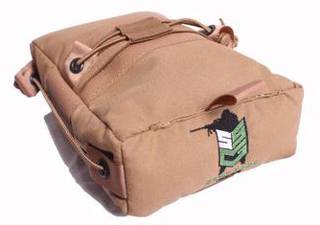
- Medium Sand Sock Gear – Because it’s shape, built-in tension cords, and ultra-light fill, the medium SSG bag is good for all-around use, especially hunting.
Sand Sock
8 - Ballistics App: We’ll be teaching you how to set up and use a ballistics app to calculate a shooting solution for any rifle/ammo combination in any atmospheric condition. There are many solid apps on the market, each with pros and cons. We’ve found the Shooter Ballistics app ($9.99) to be particularly user friendly, accurate, and economical so it has become our go-to ballistics solver for our Intro to Long Range Classes (we also use Applied Ballistics). We don’t require that you use it, but it’s strongly encouraged as all teaching aids will be based on it. Unfortunately, Shooter’s bullet library does not include bullet lengths so you’ll need to use the JBM Bullet Length List and manually enter this data in order to calculate Spin Drift. When possible, we recommend using multiple ballistic coefficients. Hornady publishes multiple BC data for their ELD-M, ELD-X, and A-tip bullets for Mach 2.25 (2515 FPS), Mach 2.0 (2232 FPS), and 1.75 (1954 fps) here - https://www.hornady.com/support/ballistic-coefficient.
Shooter - Apple iOS & Android Applied Ballistics – Apple iOS & Android
Please watch this video tutorial on how to set up your app and spend some time in the app so you’re somewhat comfortable with it when you arrive at class. Please don’t share this link as it is intended for paying students only - https://youtu.be/XmahbkpdH9M
9 - Adjustable Cheekpiece. Options:
- Add a Matthew's Fabrication Kydex Cheekpiece to your existing rifle - Use code LRSU10 for 10% OFF
- Upgrade to chassis system from LRSU like the KRG Bravo $349 - $439 MDT XRS , XLR, Masterpiece Arms, and more. Email info@longrangeshootersofutah.com
10 – In/lbs. Torque limiter & tool kit - A quality inch/pound torque limiter and tools are necessary to properly mount your rifle scope in accordance with manufacturer specifications. Damage from improperly torqued rings cause of warranty claims on optics.
Our Recommendation – Fix-It Sticks: made to the highest standards and very compact, these kits are specifically designed for precision rifle shooters. The kit includes a all-in-one 0-65 in/lbs torque limiter, all the bits and socket generally used for optics and rifles and a ratcheting T-handle which is an exclusive offering here at LRSU (normally a $40 upgrade) - Video - Buy Here or at class.
Wheeler Fat Wrench - Vortex Kit
11 – Drop Chart Holder – These small rifle-mounted drop charts put your drop data front and center next to your optic eliminating the need to break a position and consult your phone, notebook, or hand to see your D.O.P.E. saving you time and frustration.
Sidewinder - Cole Tac Cheat Sheet - X-Ring RDS - Sunrise Tactical Gear

