Long Range Shooters of Utah
Course Travel & Accommodation Information

Contact Info:
Long Range Shooters of Utah, LLC
- Bryce Bergen: 801-913-4463 (Mobile)
- Email: Info@longrangeshootersofutah.com

North Springs Shooting Range
- Rangemaster: Scott Olsen: 435-650-7728
- Email: scott.olsen@carbon.utah.gov

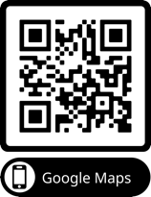
Course Location:
North Springs Shooting Range
- Address: 5245 S 8000 W, Price, UT 84501 - Google Maps. Approx. 18 mins South of Price, UT.
- All roads are paved, allowing easy access by any passenger car.
- If you plan to arrive early, the range is open from 9 am to dusk Thursday - Sunday

Closest Major Airport:
- Salt Lake City International Airport (SLC) is a 2-hour and 15-minute drive to Price, UT.
- We strongly recommend flying in no later than Thursday morning and staying in Price Thursday night to ensure you’re on-time for class Friday morning at 8:30 a.m. The range is open Thursday – Sunday 9 am to dusk.

Driving to the Range:
Google & Apple maps will sometimes direct people via dirt roads to the range which will take twice as long. All roads to the range are paved and drive time from town should be approximately 18 minutes To avoid confusion, please follow these directions starting from the Sinclair Gas Station on South Carbon Avenue, just off Exit 241 from Highway 191.
- From the Sinclair Gas Station, head southbound on South Carbon Avenue, which becomes Highway 10.
- Drive 6.9 miles to the sign for North Springs Recreation Area / Hiawatha and Turn right (west) onto UT-122.
- Follow UT-122 for 2.9 miles until you see another sign for North Springs. Turn right (northwest) onto Wattis Road.
- Continue on Wattis Road for 4.9 miles until you see the sign for North Springs on your right. Pull in.
Once you enter, you’ll cross a small gully and turn right, where you’ll find a red gate:
- If the gate is open, proceed to the main office to check-in.
- If the gate is locked, the range is still closed.
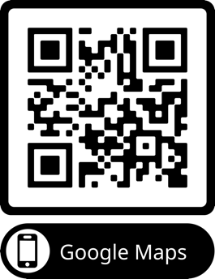
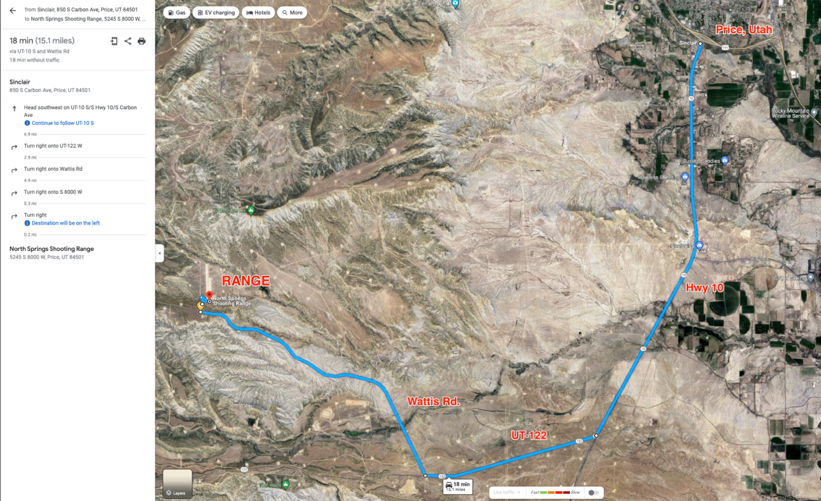
Exit 241 - Sinclair
Recommended Accommodations
Lodging options can be limited, so we recommend booking your accommodations well in advance to ensure availability.

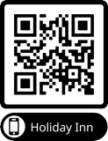
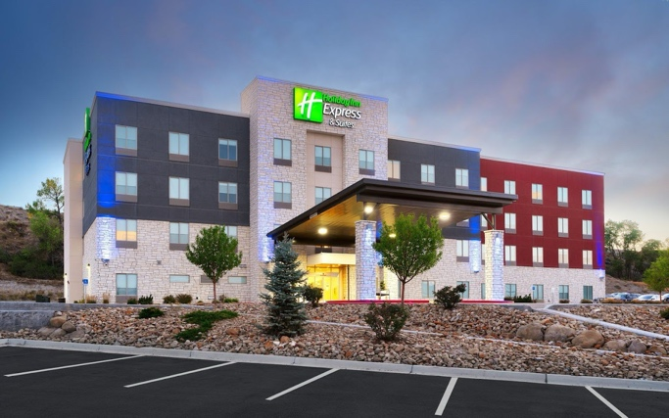

Top Recommendation
Holiday Inn Express & Suites – Price, Ut
Our top recommendation is the Holiday Inn Express, celebrated for its cleanliness, safety, and convenience.
Guests enjoy exceptional amenities, including complimentary breakfast, Wi-Fi, a gym, and a pool. LRSU students receive a year-round discounted flat rate of $129 per night (plus taxes and fees), saving up to $75 per night during peak season. To secure this exclusive rate, book directly with the hotel at (435) 637-7700 and mention Long Range Shooters of Utah.

Budget-Friendly Recommendation:
Airbnb’s: Local Airbnb’s in Price and Helper are often the most economical accommodations and have worked well for us. Many of the Airbnb’s are located in Helper which is an additional 20 minutes from the range (38 mins total).
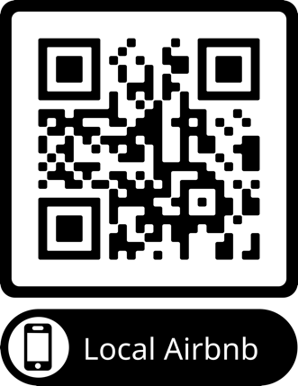
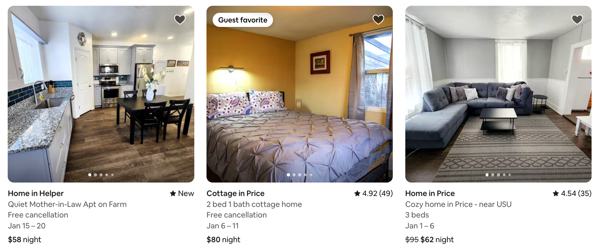

Campsites:
- North Springs Shooting Range: Primitive campsite with fire pits, benches, and porta-potties for $8/night.
On-site RV dump. Call Scott Olsen – Rangemaster at 435 650 7728 for more info.
- Blue Cut RV Park (Helper, UT): $25+/night with full hook-ups available.

Recommended Restaurants:
- Winger’s: Chicken wings, burgers, and full bar.
- Sakura Japanese Steakhouse & Sushi: Recommended Rolls: Utah, Firecracker, & Price Roll
- Grogg’s Pinnacle Brewery: Burgers are great, steaks are not.
- Balance Rock Eatery & Pub in Helper, UT: Classic American Burgers & Steaks.

Additional Discounted Hotels:
The hotels listed below also offer discounts to our students. However, please note that these are older properties with exterior-facing doors and may not offer the same standards of comfort, cleanliness, or security.
- National 9: $65/night (mention North Springs Shooting Range).
- Greenwell Inn & Suites: $77–$95/night (mention Long Range Shooters of Utah).
- SureStay Plus by Best Western: $99+/night, including breakfast (mention Long Range Shooters of Utah).

Schedule:

Friday
- 8:30 am – Check-In at the Main Office & Pay $10/day range fee ($20 total)
- 8:45 am – Class begins in the classroom within the main office.
- 12:30 pm – 45 min Lunch Break & rental orientation (Please bring a sack lunch)
- 1:15 pm – Class resumes.
- 4:00 pm – Zeroing & Setup at the 100-yard range for approximately 30-90 mins

Saturday
- 8:00 am – Meet at the 100-yard range.
- 9:00 am – 10:30 Paper Drills
- 10:30 am – Partner-up and move to the 1000-yard range.
- Noon – Lunch break
- 2:30 - 1000-yard Milk Jug Challenge
- 4:00 pm – Class photo and the conclusion of formal training.
- Open Range & Optional 1200 through 1 Mile Milk Jug Challenges ($20 per 10-shot attempt)

Buffalo Canyon
Cowboy Town

Law Enforcement
a
Over-the-Edge

600 Yard
Range

Archery
Barnes Shed
1200, 1500 & 1 mile

1000 Yard
Range

Campground

To Price
100 Yard & Pistol
Range

Main Office

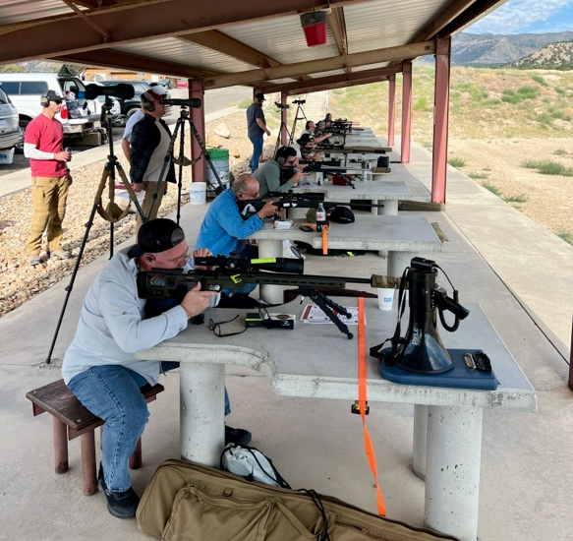
Be Prepared for Utah Weather:
Utah’s high desert climate can change quickly, so check the forecast and come prepared for the worst-case scenario to ensure comfort and focus during class.
The classroom is indoors, and all shooting positions are covered, featuring concrete shooting benches, stools, and open areas for prone shooting. Loaner shooting mats are available upon request.
- Early Spring/Late Fall: Expect temperatures between 25°–60°F with potential for snow. Layers, gloves, handwarmers, and stocking hats recommended.
- Summer: Expect 60°–90°F with the possibility of afternoon thunderstorms.

Personal Sustainment:
Students should bring a sack lunch, beverages, and snacks each day, as there won't be enough time to make the
40-minute round trip to town during class. Day 1 includes a 45-minute lunch break and two 15-minute bathroom breaks, while Day 2 allows for flexible breaks and meals at your convenience.
- For those flying in, there is limited fridge space available in the main office.
- Free coffee is available in the mornings, and the range has a selection of sodas and energy drinks for sale.
- Restroom facilities are available at the main office in addition to porta potties throughout the range.
Prohibited Items:
- No alcohol or drugs are allowed at North Springs Shooting Range or our classes.
- No Smoking within 100 feet of any structures or patrons.

Required Equipment:
Your success in this course depends on arriving well-prepared with the right equipment. A detailed equipment checklist is provided separately—please review it carefully and test your gear beforehand to ensure it meets our 1 MOA minimum requirement. If you have any questions about your equipment or what to bring, don’t hesitate to contact us. To simplify preparation and reduce stress, consider our complete rental packages. These packages ensure you meet all requirements and allow you to focus entirely on the curriculum.
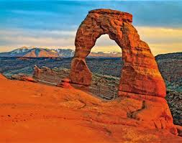
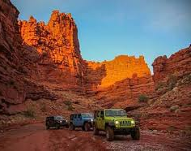

Extend Your Stay and Enjoy Utah!
Price, Utah is 1-2 hour’s drive from some of the most iconic national parks in the world.

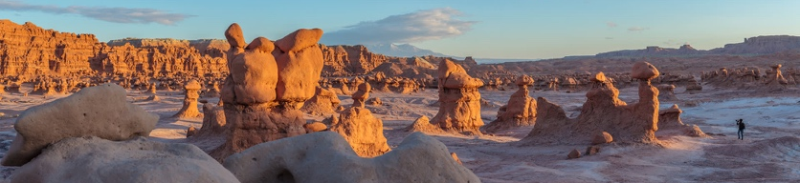
Moab, Utah— (116 mi.) The gateway to Arches and Canyonlands National Parks. Rent a Jeep, UTV, or mountain bike and explore Moab’s world-famous red rock trails, guided river rafting, and lively downtown restaurants & shops.

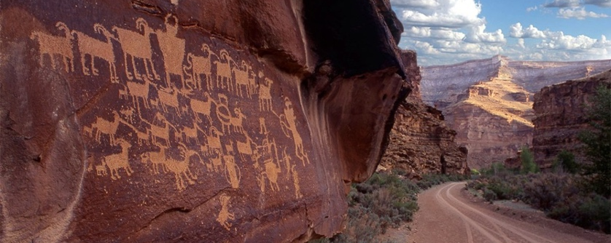
Goblin Valley State Park – (110 mi.) Goblin Valley State Park features a stunning landscape of unique, mushroom-shaped rock formations, perfect for hiking, exploring, and photography, offering a truly otherworldly experience.

Nine Mile Canyon – (109 mi.) Often called the "World's Longest Art Gallery," featuring countless ancient Native American petroglyphs.

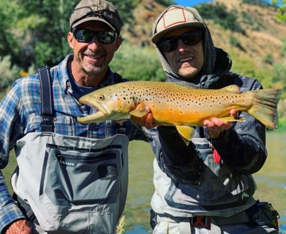
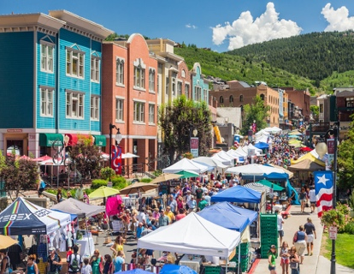
Park City, Utah – (124 mi.) A world-class ski destination in winter, Park City transforms into a vibrant summer getaway with scenic mountain views, hiking and biking trails, zip-lining, alpine slides, and outdoor concerts. Visitors can stroll historic Main Street’s shops, art galleries, and restaurants or enjoy activities like guided fly fishing, hot air ballooning, and golfing.

Midway, Utah – (106 mi.) swimming and scuba diving in the Homestead Crater, hiking and golfing in Wasatch Mountain State Park, and a charming Swiss-inspired vibe perfect for a relaxing getaway.

